MASTER SERVICES AGREEMENT
This Master Services Agreement (the “Agreement”) is entered into as of March 4, 2026 (the “Effective Date”) by and between Halvorsen Marine Logistics, Inc., a Delaware corporation with offices at 4410 Quayside Drive, Norfolk, Virginia 23510 (“Client”), and Brightwater Analytics LLC, a Colorado limited liability company with offices at 918 Pearl Street, Boulder, Colorado 80302 (“Provider”).

1 Definitions
- “Deliverables” means the reports, dashboards, and data models that Provider prepares for Client under a Statement of Work.
- “Statement of Work” or “SOW” means a document executed by both parties that describes specific services, fees, and milestones.
- “Confidential Information” means non-public information disclosed by either party, including:
  - pricing, vessel schedules, and customer lists;
  - source code and model weights; and
  - the terms of this Agreement.

2 Services and Fees
Provider will perform the services described in each SOW. Client will pay the fees listed below within thirty (30) days of each invoice. Late amounts accrue interest at 1.25% per month or the highest rate permitted by law, whichever is lower.
Table 1. Fee schedule
Service | Unit | Rate (USD) | Monthly minimum
Route analytics | Per vessel | 1,850.00 | 12,950.00
Port congestion feed | Per port | 640.00 | 3,200.00
Custom modeling | Per hour | 285.00 | None
Onboarding | One-time fee of 7,500.00, invoiced on the Effective Date

3 Term and Termination
The initial term begins on the Effective Date and continues for twenty-four (24) months. Either party may terminate this Agreement:
- for convenience, on ninety (90) days’ written notice;
- for material breach that remains uncured thirty (30) days after written notice; or
- immediately, if the other party becomes insolvent or makes an assignment for the benefit of creditors.
Sections 4, 5, and 7 survive any expiration or termination of this Agreement.

4 Confidentiality
Each party will protect the other party’s Confidential Information with at least the same degree of care it uses for its own, and no less than reasonable care. A receiving party may disclose Confidential Information to its employees and contractors who need to know it and who are bound by written obligations at least as protective as these. The obligations in this Section last for five (5) years after termination, except for trade secrets, which remain protected for as long as they qualify as trade secrets under applicable law.

5 Limitation of Liability
EXCEPT FOR BREACHES OF SECTION 4, NEITHER PARTY WILL BE LIABLE FOR ANY INDIRECT, INCIDENTAL, SPECIAL, OR CONSEQUENTIAL DAMAGES. EACH PARTY’S TOTAL LIABILITY UNDER THIS AGREEMENT WILL NOT EXCEED THE FEES PAID OR PAYABLE IN THE TWELVE (12) MONTHS BEFORE THE CLAIM AROSE.

6 General
This Agreement is governed by the laws of the Commonwealth of Virginia, without regard to its conflict of laws rules. This Agreement, together with each SOW, is the entire agreement between the parties on its subject and supersedes all prior proposals and understandings.
IN WITNESS WHEREOF, the parties have executed this Agreement as of the Effective Date.
HALVORSEN MARINE LOGISTICS, INC. | BRIGHTWATER ANALYTICS LLC
By: ______________________________ | By: ______________________________
Ingrid Halvorsen, Chief Executive Officer | Tomas Okafor-Reyes, Managing Member

Q3 2026 Port Throughput Review
Container volumes at the six monitored East Coast ports rose 6.8% from the second quarter, led by Savannah and Norfolk. Average berth wait time fell to 19.4 hours, the lowest since the fourth quarter of 2023.
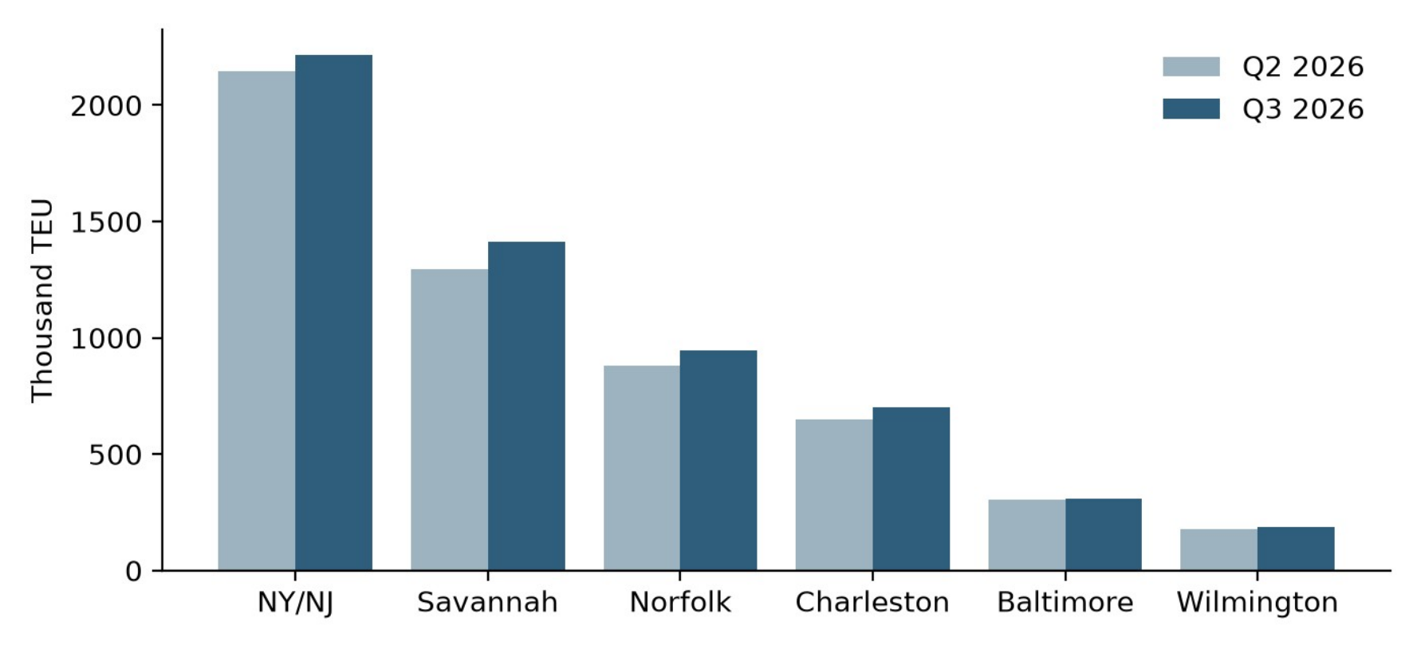
Figure 1. Container volume by port, Q2 and Q3 2026 (thousand TEU)

Highlights
Savannah handled 1,412 thousand TEU, up 9.1% on the quarter, after its fourth berth reopened in July. Norfolk grew 7.6% on new transatlantic services. New York and New Jersey remained the largest port by volume, though its growth slowed to 3.2% as two terminals ran reduced hours during crane replacement.
Charleston and Baltimore recovered from second-quarter disruptions. Charleston’s volume rose 8.4%, and Baltimore returned to its 2025 average after the channel restriction was lifted on June 2.

Risks for Q4
- Labor contract talks at two terminals in New York and New Jersey resume on November 3.
- Hurricane season closures cost an average of 2.6 operating days per port in 2025.
- Chassis shortages persist in Savannah, where dwell time for imports reached 5.9 days in September.

Outlook
We expect fourth-quarter volumes to rise between 2% and 4%, with the strongest growth in Norfolk. Wait times should stay below 22 hours unless weather closes more than one port at once.
Port | Q3 TEU (k) | Change
New York/NJ | 2,214 | +3.2%
Savannah | 1,412 | +9.1%
Norfolk | 948 | +7.6%
Charleston | 702 | +8.4%
Baltimore | 311 | +1.9%
Wilmington | 186 | +4.5%

Provider was formerly known as Brightwater Data Partners LLC and changed its name on January 15, 2025.
Interest is calculated daily on the unpaid balance from the due date until payment is received in full.
For clarity, Section 4 (Confidentiality) survives for the period stated in that Section, and payment obligations accrued before termination survive until paid.

